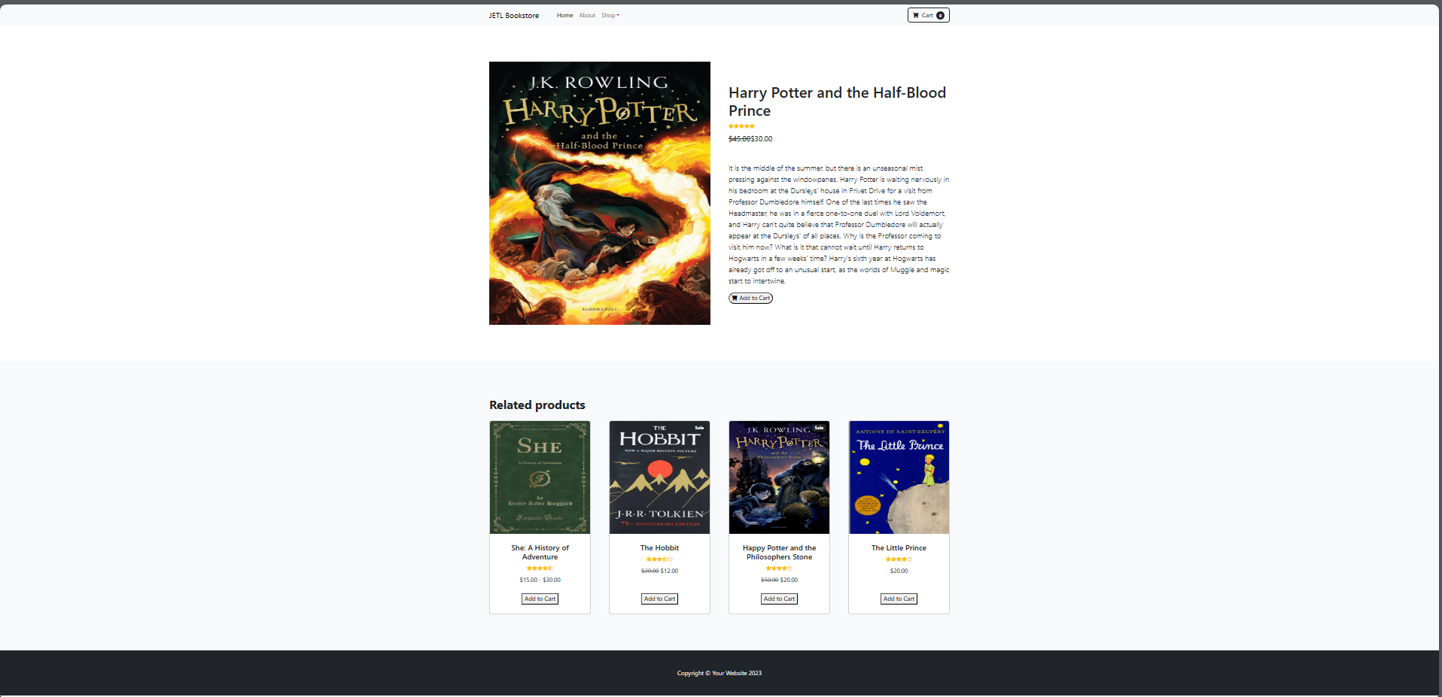  
  
  
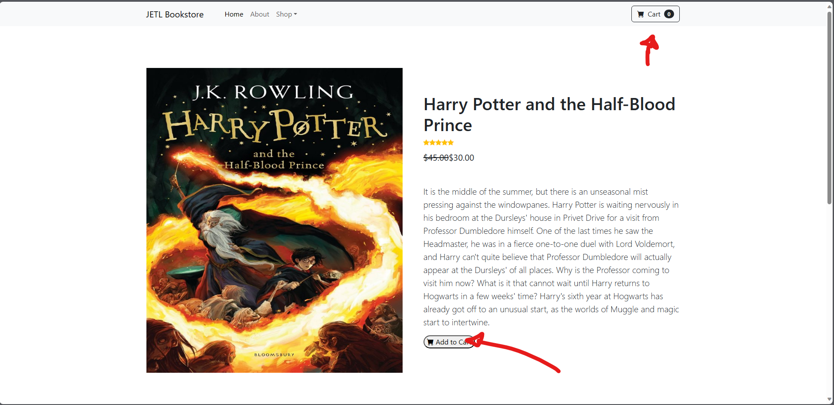

When you click add to cart, as you can see in the upper right, the cart value will be appended based on how many items the user added to cart.

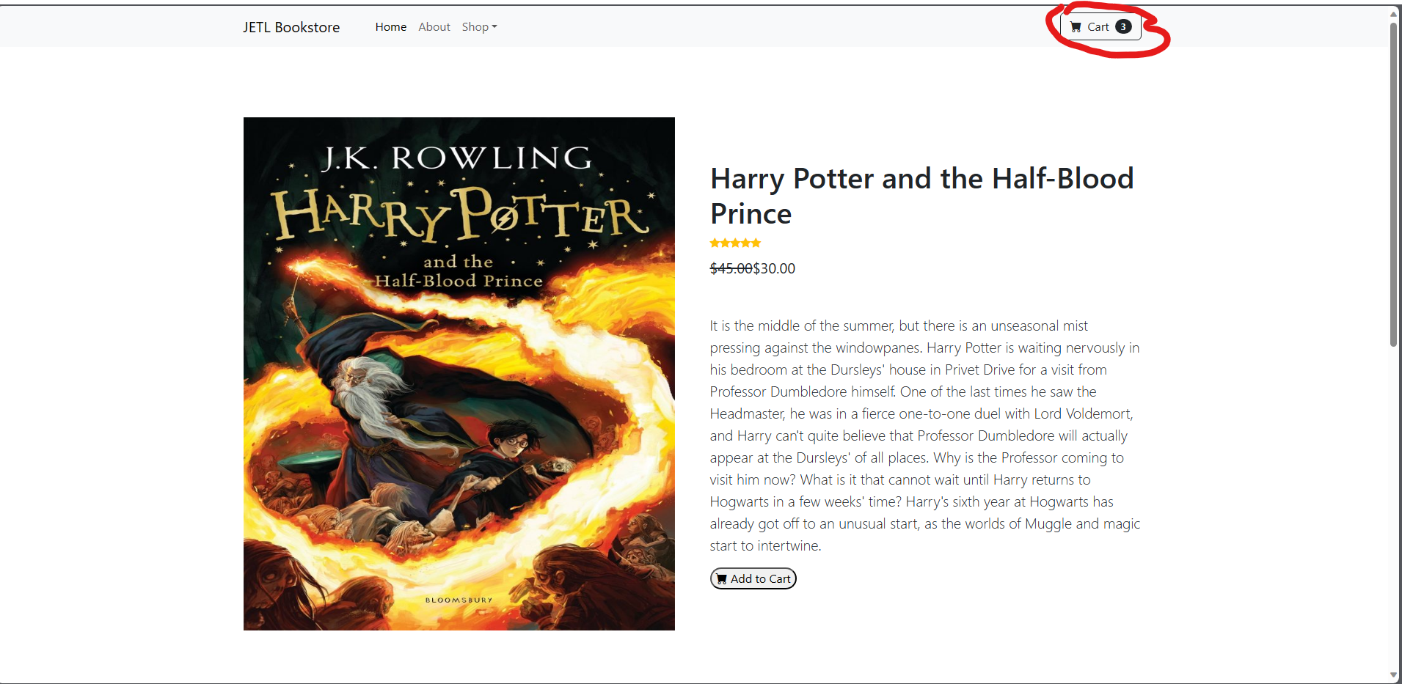

As you can see here user added 3 books in cart.

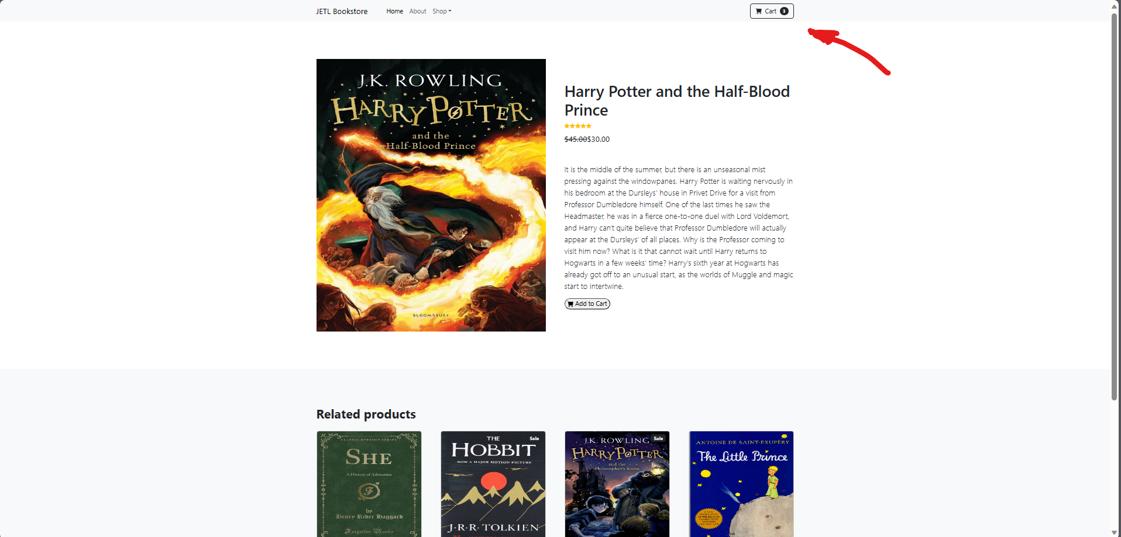

If the user wants to reset or clear all of his orders, he/she must click the cart button again.

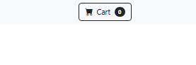

That’s the data binding that I use.

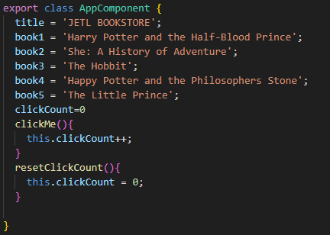

I have made a lot of components that I can call out, but instead of using text words, I use variables to get the value of it.

Example:

